Holistic Model Home –Investment Information:

Note: follow the stars (*) for further details

We are building a Model Home at our Community Prototype Site to showcase the possibilities of an Earthship-Inspired Holistic Home in a Northern Climate, and to provide a solution to a problem that many of us face. As conventional housing has failed to keep pace with our rapidly changing world, we are vulnerable to circumstances beyond our control. To address this, we’re offering these buildings as an extremely viable, affordable & sustainable option. In the year of 2020 –a time of drastic change- and we are presenting a long-desired solution.

We will be building one of our smaller designs, called the Fibonacci.1 –single unit, 1 bathroom & a double greenhouse (1,100 sq’ in total). This building has the bedroom, kitchen & living area all in the same U-shaped tire wall, with a curtain at the end of the bed for privacy. The bathroom is in the inner greenhouse, while the outer greenhouse is completely dedicated to growing plants & food. This design is the smallest in our Fibonacci Collection, and is an excellent representation of our Holistic Homes –it is large enough for a couple or small family to live comfortably, and is financially attainable for most people.

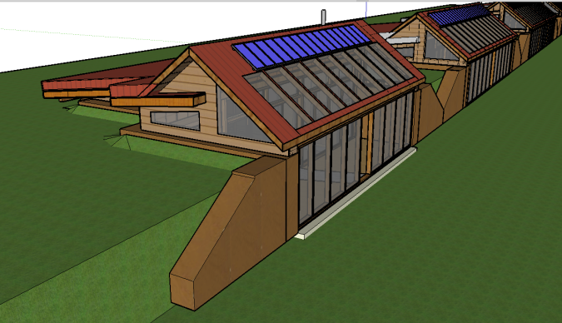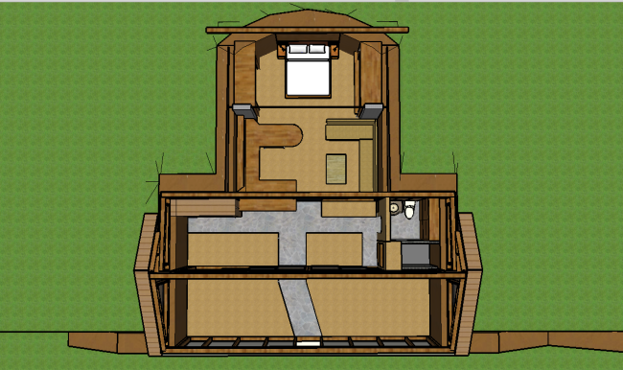

This building requires $144,000 to build, and we’re looking for 144 investments of $1,000. An individual can contribute $1,000 or more to become an investor for this building, and multiple individuals can work together to collectively purchase a $1,000 investment.

We accept all forms of currency that can be converted into Canadian Dollars (CAD). As we currently reside in Canada, we will be purchasing building materials with CAD; therefore, your investment/donation will be processed in CAD.

For those who invest $1,000 or more, we are offering:
- 21% off the cost for enrollment & participation in our Internship Program *
- Entry into a draw for the opportunity to name the building **
- Talking Trees t-shirt (1)
  - Black, White OR Tie Dyed

You will also have the opportunity to choose your preferred Return on Investment (ROI).
The options are as follows:
- 0.7% (1/144th) of the rental profit, paid out annually for 13 years ***
OR
- 7 night stay in the rental/Holistic Model Home
OR
- Donation

* We will be offering an Internship Program as an opportunity to teach people how to build their own Holistic Home, and become a part of the crew that will build this Model Home. If you become an investor and choose to participate in this Program, you will receive a 21% discount to enroll.

** Each individual or group name will be entered into a draw, and one will be picked at random. The individual or group who is drawn will be able to name the Holistic Model Home.

*** Upon completion, this Model Home will become a rental for nightly, weekly & monthly stays; therefore, this ROI option will be dependent on the rental income for this home.
Annual payouts will be on June 21st (beginning in 2021 & ending in 2033). This return is completely dependent on the income for this rental. A portion ($10,400) of the income will go towards maintaining the building & paying the salary of the individual who takes responsibility for this job. The remainder of the income for this rental will be divided between 144 ways (0.7% return per share).

While we are open to having 144 separate investors, we encourage individuals & groups to purchase multiple shares. Everything* mentioned above will still apply, however multiplied based on the amount of shares purchased.
For example: If 5 shares are purchased at $5,000, that individual or group would receive:
- 5 entries into the draw to name the building
- 5 shares of the rental income **
OR
- 35 nights in the rental

* The only aspects that do not change when purchasing multiple shares is the 21% discount for the Internship Program, and the t-shirt.

** Example: If the return for one year is $300, purchasing 5 shares means that year’s return is multiplied by 5 ($1,500).

If you’re interested in becoming a Talking Trees Holistic Model Home Investor, please make sure you fully comprehend this document before filling out our Investor Registration Form. Once we have received said form, we will contact you for further details.

Talking Trees Model Home Rental:
Estimated Income, Expenses & Profit Breakdown–

Income: (Prices for staying in the rental for a night, week or month)
Nightly Rental --- $144
Weekly Rental --- $850
Monthly Rental --- $3,300
Expenses (Yearly):
Personal (Salary) --- $7,800
Building & Site Maintenance --- $2,600
Total --- $10,400

Bookings needed to cover expenses ($10,400):
Nightly --- 73/365 days (20% of the year)
Weekly --- 13/52 weeks (25% of the year)
Monthly --- 3.5/12 months (30% of the year)

Maximum Yearly Income:
(Max. income if rental is booked for 365 days/52 weeks/12 months)
Nightly --- $52,560
Weekly --- $44,200
Monthly --- $39,600

Maximum Yearly Profit:
(If the rental is booked every night/week/month, and the expenses are $10,400 a year, this would be the profit divided amongst investors)
Nightly --- $42,160 *
Weekly --- $33,800 *
Monthly --- $29,200 *

Estimated Yearly Return:
(When the above* figures are divided 144 ways, this would be the yearly profit for each investment)
Nightly --- $290 (x13years = $3,770)
Weekly --- $235 (x13 = $3,055)
Monthly --- $203 (x13 = $2,639)

Alternate Possibility #1:
(If the rental is booked 50% of the time– 182 days/26 weeks/6 months)

Income:
Nightly --- $26,208
Weekly --- $22,100
Monthly --- $19,800

Profit (Income minus expenses)
Nightly --- $15,808 *
Weekly --- $11,700 *
Monthly --- $9,400 *

Estimated Yearly Return:
(When the above* figures are divided 144 ways, this would be the yearly profit for each investment)
Nightly --- $110 (x13years = $1,430)
Weekly --- $81 (x13 = $1,053)
Monthly --- $65 (x13 = $845)

Alternate Possibility #2:
(If the rental is booked 75% of the time– 270 days/38 weeks/9 months)

Income:
Nightly --- $38,880
Weekly --- $32,300
Monthly --- $29,700

Profit (Income minus expenses)
Nightly --- $28,480 *
Weekly --- $21,900 *
Monthly --- $19,300 *

Estimated Yearly Return:
(When the above* figures are divided 144 ways, this would be the yearly profit for each investment)
Nightly --- $198 (x13years = $2,574)
Weekly --- $152 (x13 = $1,976)
Monthly --- $134 (x13 = $1,742)

This return is dependent on the yearly profit for the rental, which will be divided 144 ways and paid to each investor. Based on the figures laid out in this document, the range for this Return on Investment is between $60 and $300 a year; $850 – $3,770 over 13 years! Moreover, based on the research we have done into the booking rates for other comparable Earthships/Earthship-Inspired rentals, we can anticipate this building to be rented, at least, 75% of the year. Therefore, a more accurate estimated range of yearly/total return would be $130 – $200 a year/$1,700 – $2,600 in total over 13 years.

If you are interested in seeing the research we have done into rental rates for comparable buildings, please consult our Rental Research document on the Holistic Model Home Investment page of our website.

